# Presidential Initiative for Artificial Intelligence and Computing (PIAIC)

**PIAIC Batch 4-35 IoT**

https://www.piaic.org

Internet of Things (IoT) Specialist Program

Quarter 2: Rust Programming

**Assignment # 2**

1. Define Traits in your own words?

**ANSWER:**

Traits are a way to group method signatures together to define a set of behaviours necessary to accomplish some purpose.

1. Illustrate with an example how using Traits can help you organize your code and reduce duplication in your program

**ANSWER:**

For user defined data types like Car, Aeroplane, Train can implement a trait called speed which is common in all three data types.

1. Write a rust program:
   1. Define a struct IOT_student with attributes (name, age, education).
   2. Define another struct IOT_instructor (name, age).
   3. Define a trait Questions with method ask_Questions with a default implementation which prints (“Zoom session will be LIVE, Zoom recording will not be available. Quarter 2 studio recorded videos are available on Portal.”).
   4. Impl trait Questions for IOT_instructor which overrides the default implementation of method ask_question, takes student name as a parameter and prints on screen (“{} In case of any issue email to education@piaic.org”).
   5. Create instances of both the structs and call Method ask_question.

**ANSWER:**

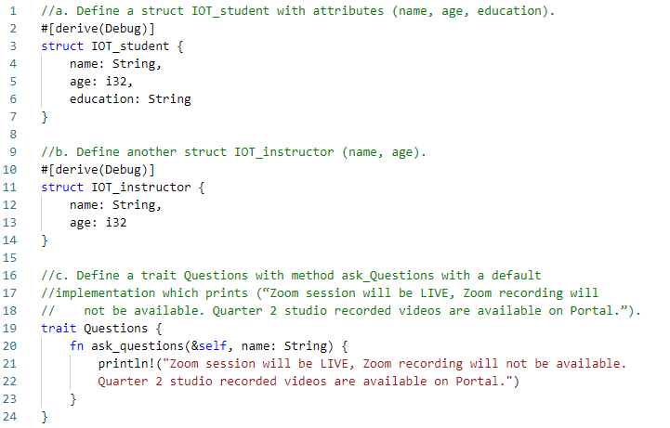

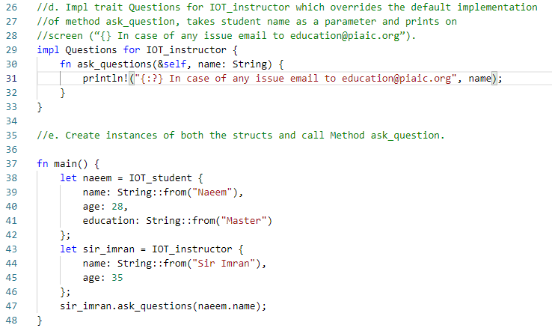

1. Go through the solution of the largest function given at the end of 10.2 in the book and rewrite the solution but this time returning the smallest item instead largest.

